Discord Web Site Test

Introduction

This project is built to test discord and move it to a better place !

Discord has 2 billion dollars value ;currently 200 million messages per day ,6 billion messages per month and 9 million active users using the program daily (approximately 20% of these usages for website platform).

Testing Results

In this project I have used selenium IDE to generate basic automated codes.I have edited and carried less bugged situation of selenium IDE’s auto generated code in JAVA.

Boundary analysis is brief and is made to attack critical points and worked !

Found three errors and one non-user friendly situations as reported in the video.

*Non existent mail approved and sent verification message by Discord !

*Username accepted which contains just signs ! (tagging difficulty for users)

*Accepted friend requests from non-verified accounts may harmful for low age people with harmful broadcasts.

*Creating channels with same name causes conflict in users.Names should be created as windows file naming system which does not allow to create same named file in the same folder.

I have used WebDriverWait to not to fill login page’s email fields and waits until register button is clickable otherwise if fields are downloading faster than compiling code, fills login screen’s email field and gives error

I have solved like this;

driver.findElement(By.*linkText*("Giriş")).click();

//To Go Registration Page With a Sublink !  
WebDriverWait waitRegisterPage = new WebDriverWait(driver, 15);   
waitRegisterPage.until(ExpectedConditions.*elementToBeClickable*(By.*cssSelector*(".smallRegisterLink-2LCrMe > .contents-18-Yxp"))).click();  
  
driver.findElement(By.*name*("email")).sendKeys("nonexistentmail11@gmail.com");

Why do we used load testing ?.

Load testing is defined as a type of software testing that determines a system's performance under real-life load conditions.

* Load testing typically improves performance bottlenecks , scalability and stability of the application before it is available for production.
* Loading testing is important because if ignored, it causes financial losses.

Performance test made by GTmetrix and basic load testing have done by Blazemeter for 1.7 MB main discord web page . In load testing ,although increase in number of active users discord’s response time(TTFB) did not fluctuate, this shows this number of 50 users and around 100 clicks per second not a big deal for discord servers.Discord successfully passed the test and met the Google’s response time recommendation accurately ! 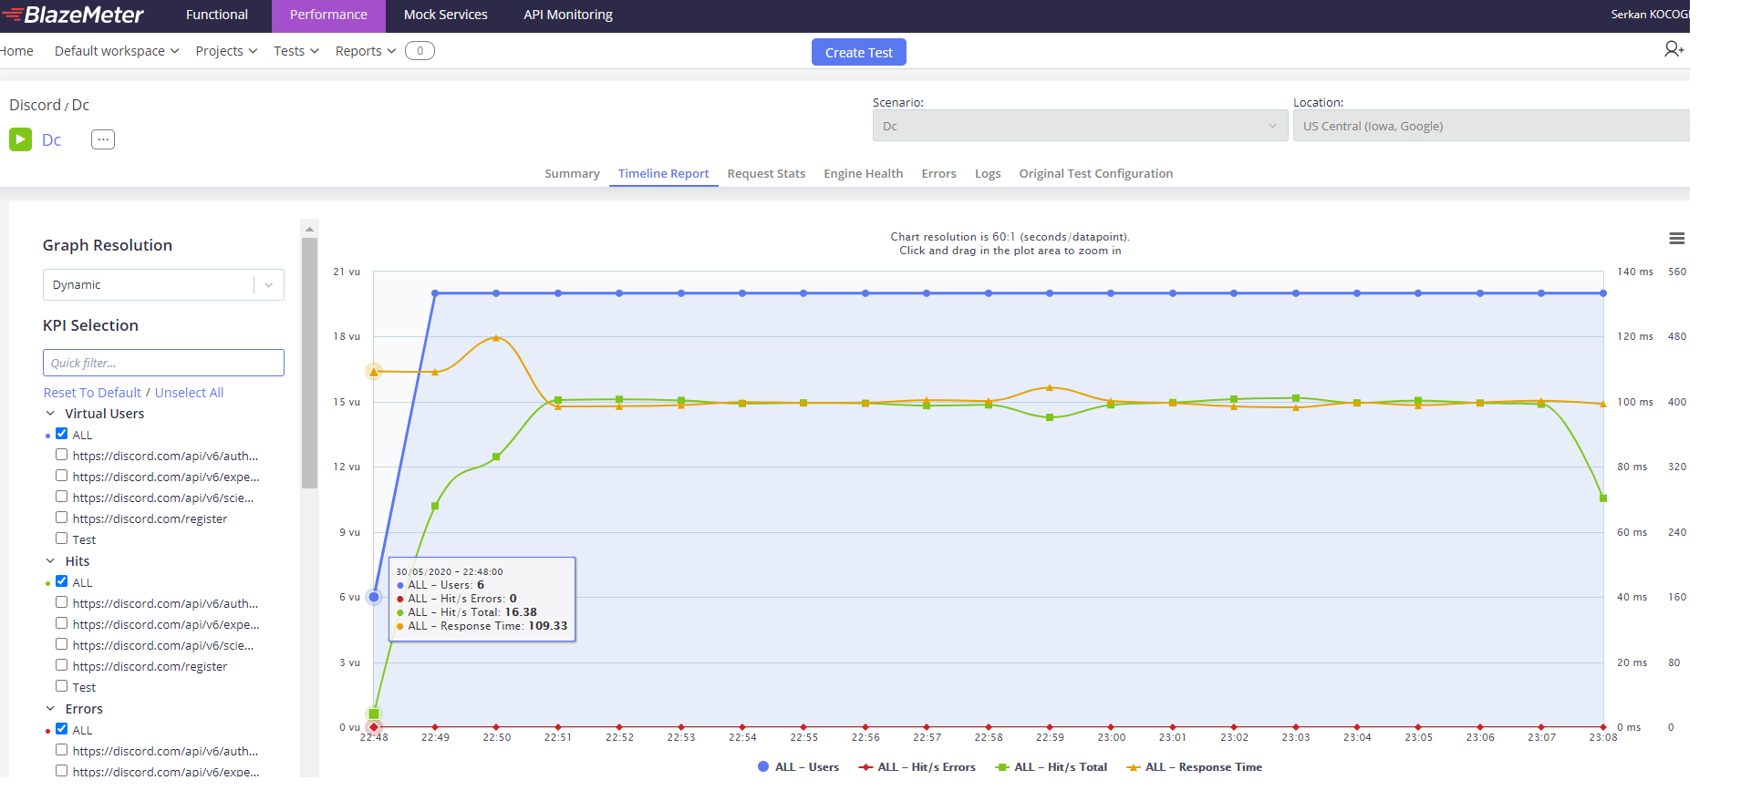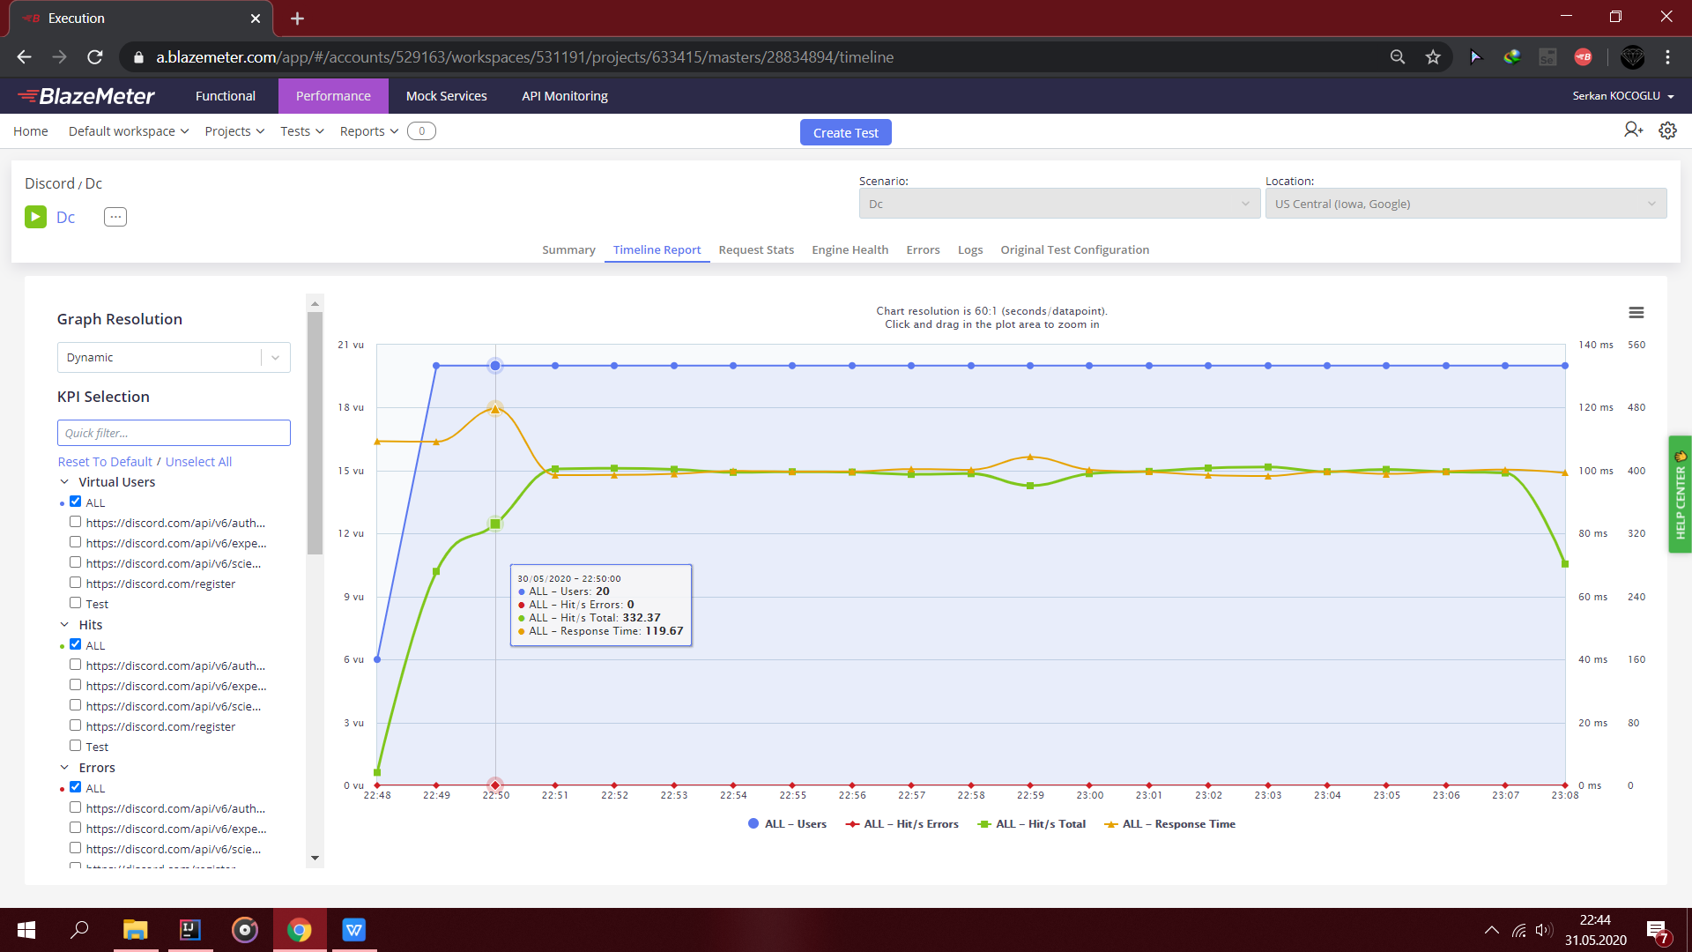

By loading 6 to 20 active users with 332 hits/s response time increased from 109.33 to 119.67.After this fluctuation any important change is not observed.

Conclusion

For a future work,scheduled an appointment with discord inc. about white box testing.

All in all ,although discord has such a big place in the market share , are not able to pass our tests successfully.Reviewing these reported four problems may helpful.However loaded response times are good enough even at the peak usages.

(<https://status.discord.com/>)

Notes for usage

* If program works consecutively it may give error because discord banns by IP or tests by reCaptcha.

*While testing, if enters to the system do not forget to change email to that not used before.

Youtube report link:https://youtu.be/1_KRuWxVLhs

Serkan Koçoğlu

Best Regards..